Name: ___________________________ Essential Knowledge quiz

- Resisters convert Electrical Energy into what form?

- If you double the length of a wire the resistance will? _______________
- What is the total resistance below?
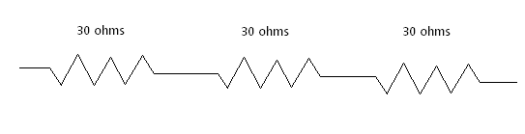

- What is the total resistance below?
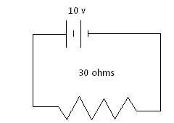
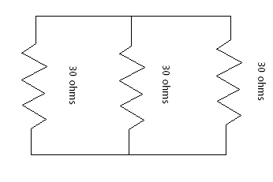
- What is the current in the circuit below?

6. Use words to explain Kirchhoff’s Loop Rule

7. Use words to explain Kirchhoff’s junction rule.

